DAY 1 JAIPUR – CHANDIGARH - SHIMLA

In time transfer to airport to connect flight for Chandigarh.

Current Flight Schedule:
Depart: Jaipur At: 1310 hrs
Arrive: Chandigarh At: 1450 hrs
(The above timing is as per the current schedule, subject to change)

Arrive Chandigarh airport & directly driven to Shimla (Approx 120 Kms / 4 hrs)

Shimla
Shimla is in the enriched state of Himachal Pradesh which boasts of nature’s generous bounty, reflected in its beautiful landscape, comprising of exotic valleys, snow-capped mountains and crystal blue lakes set amidst lush rolling hills, rich with the fragrance of pine and cedar. Discover intriguing private gardens in the richly forested foothills of the Himalayas, set around fine old houses, redolent with the echoes of a colonial past

Rest of the day at leisure for independent activities

Overnight at hotel - Shimla

DAY 2 SHIMLA

Buffet breakfast at hotel

Morning: Transfer to Shimla railway station for a toy train ride
Enjoy a short ride on the renowned Kalka-Shimla toy train. Built in 1903, this track is an engineering marvel, with 103 tunnels and 700 non-girder bridges in a distance of only 96 kilometers and more than two-thirds of the entire track on curves, some as sharp as 48 degrees. It is also distinguished as one of UNESCO World Heritage Sites. The toy train chugs along the line, whistling through the deodar, pine, ficus, oak and maple woods at a speed of 22 kilometers an hour. As the journey begins, one is taken in with the change in vegetation, and the majestic glory of the railway stations and Gothic-style bridges en route. After an exciting short toy train ride, you shall disembark at Solan and drive back to Shimla
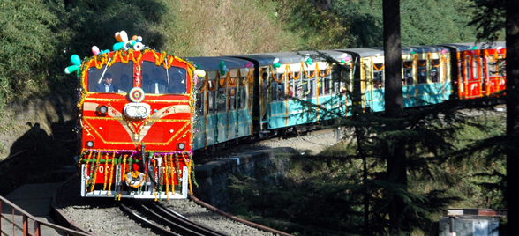

Toy-train Journey
Depart: Shimla At: 10:30 hrs By: 52456 Himalayan Queen
Arrive: Taradevi At: 11:20 hrs (operates daily)

On disembarking the train at Taradevi drive back to Shimla (Approx 53 kms/ approx 1 hrs)

Afternoon: Sightseeing tour of Shimla
Visiting The Mall, the main promenade that runs along the top of the ridge, a busy shopping area with old colonial buildings, souvenir shops and restaurants. At the top end of the Mall is Scandal Point, a large open square with a view of the town. Overlooking it is the elegant Christ Church with its fine stained glass windows; Visit vice regal lodge (formerly the residence of the British Viceroy); the Himachal State Museum (closed on Mondays), which has a modest collection of stone statues and local handicrafts from different parts of Himachal Pradesh.

Following sightseeing tour, return back to hotel

Overnight at hotel - Shimla (B)

DAY 3 SHIMLA

Buffet breakfast at hotel

Full day at leisure for independent activities (No vehicle at disposal)

Overnight at hotel - Shimla (B)

DAY 4 SHIMLA - CHANDIGARH - DELHI

Buffet breakfast at hotel

Morning: At leisure for independent activities (No vehicle at disposal)

Check Out: 12 Noon

Afternoon: You will be driven to Chandigarh (Approx 120 Kms / 4 hrs)

Late Afternoon: Arrive Chandigarh & transfer to Chandigarh railway station to board train to Delhi

Train Journey:
Depart: Chandigarh At: 18:23 hrs by 12012 Kalka Shatabdi Express
Arrive: New Delhi At: 21:55 hrs Class – Air conditioned Chair Car
(The above timing is as per the current schedule, subject to change)

Evening: Arrive New Delhi railway station & transfer to hotel for 01 night's stay

Overnight at hotel – New Delhi (B)

DAY 5 DEPART DELHI BY: TBA AT: TBA

Buffet breakfast at hotel

Morning: You will be met by our representative will meet at the hotel lobby and transfer you to the New Delhi international airport to board flight to onward destinations

END OF OUR SERVICES

